Creating a Direct Ship in P21

**Customer Service will be entering Direct Ships **

- Enter your order in the normal manner.
- At the Header, ‘Create RFQ/PQ box will be checked and if you have Direct ship lines when you save this order it will automatically start the PO process. If this is checked and your lines are set at S or B it will not process any Purchase Orders. (At Neff and C & E, if left checked, it will cut a PO for ‘S’ disposition lines.)
  - Review your customers PO shipping instructions and your sales order Carrier, Freight Code, Delivery Instructions this information WILL PULL TO your Direct PO
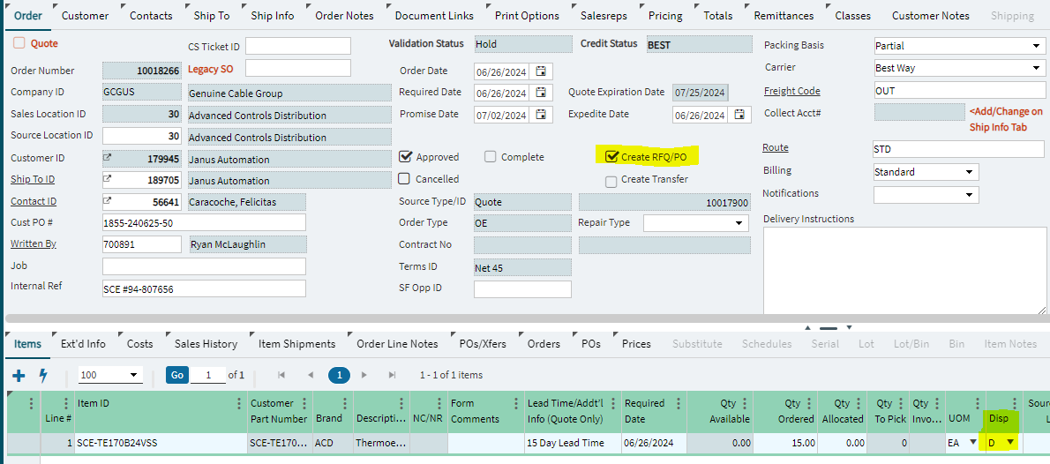
- At the line (part) level, choose DISP code – ‘D’. This needs to be done for each item that is being Direct Shipped.
  - Do you have the correct source location for this line for your location?
  - Have you met all supplier direct ship minimum shipping requirements?
  - Are you allowed to ship this supplier direct?
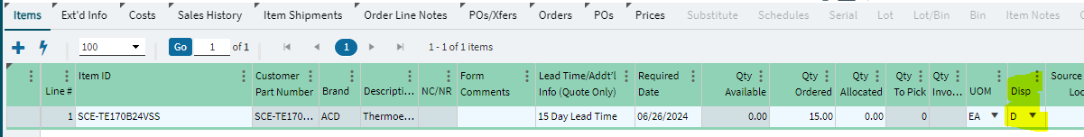
- Complete your order entry and hit Save Order
  - If your customer order is on Validation HOLD you will NOT be able to process the Direct shipment you have to contact the Credit Officer to release it first.
  - Once it is released you can go back into the order and now check Create RFQ/PO
- Create RFQ/Purchase Orders from OE Wizard will appear.
  - If you accidentally processed this order as a direct and want to cancel you go to the bottom of this screen and hit CANCEL and then you stop the entire process and go back to the beginning.
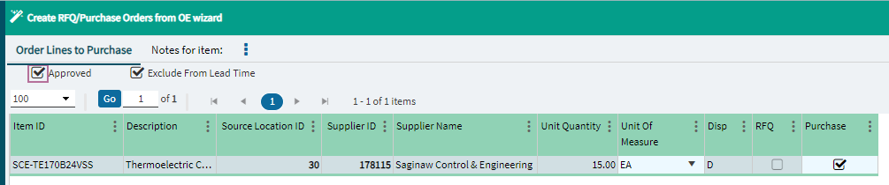

- Confirm the items you want Direct Shipped and choose Next at the bottom right of the screen.
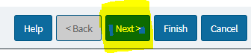
- The second portion of this same screen will appear
  - External PO number auto-populate the customer’s PO # from your Sales Order
  - Carrier ID:
    - Is your customer collect? It will pull from your sales order and auto-populate the collect information and follow step 7, c.
    - Are you shipping Pre-Pay and add?
      - YES
        - Change your carrier ID to BEST WAY
        - Auto-popuated Shipping Instructions are no longer available in this screen
          - ANY Shipping Instructions you put on the Sales order come over to the Vendor PO
  - Choose how you want to send your PO to the vendor. For this example, I am emailing the PO.
    - You can send NON-SOFTWARE order to Siemens by choosing EDI
      - Before you do this you need to make sure that you are not sending incorrect part numbers or items that have multiple qty requirements. To check this you can export your lines from your PO and import them into the Siemens iMall and check
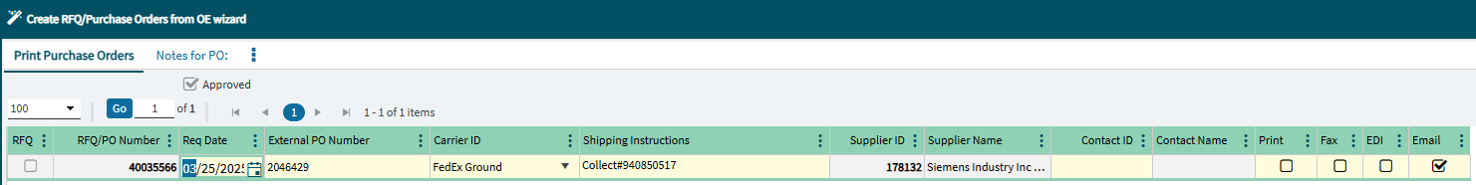
- Choose Finish at the bottom right of the screen.
- Review supplier email address
  - You can check the CC USER so that you get a copied emailed to you also.
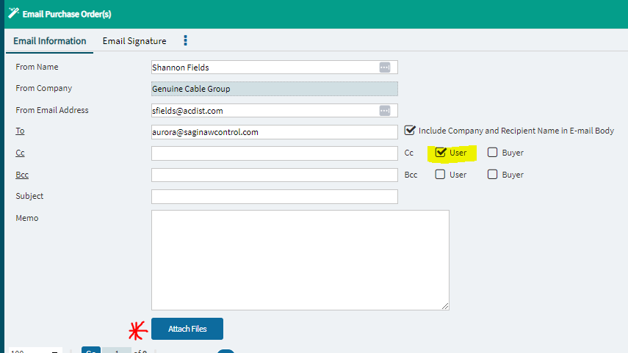
- Click OK at the bottom right of the screen.

